Dairy read
The opening half of Large Dairy Herd Management (3rd ed.) sets the stage for understanding how modern dairy operations function at large scale. It begins with a focus on sustainability and capacity building, stressing that profitability and long-term viability depend not only on milk output but also on resource stewardship, environmental management, and strategic planning. Authors emphasize that large herds magnify both opportunities and risks: efficiency gains are possible, but so are costly errors if systems are not carefully designed.
From there, the text shifts to the structure of large herd systems, detailing how scale requires a systematic approach to workflow, record-keeping, and labor organization. Facility and environmental design receive particular attention, highlighting how barn layout, ventilation, heat abatement, and manure management directly influence cow comfort, productivity, and welfare. Effective infrastructure is shown to be foundational, since it shapes the daily rhythm of both animals and employees.
Economic realities are introduced through discussions of milk markets and marketing. The book underlines the volatility of milk prices and the importance of risk management, contracts, and quality assurance programs. These sections stress that market awareness and economic analysis are as critical as animal care in sustaining profitability.
The mid-sections turn to genetics, breeding, and youngstock management. Advances in genomic testing and child selection are presented as transformative tools for improving productivity and disease resistance, but the authors caution that genetic progress must align with herd goals and management capacity. Calf and replacement heifer programs are portrayed as long-term investments: nutrition, colostrum management, and disease prevention in the first weeks of life strongly influence lifetime performance and herd turnover costs.
Vensim
I created a population model, with a stock representing the population, and births and deaths acting as flows.
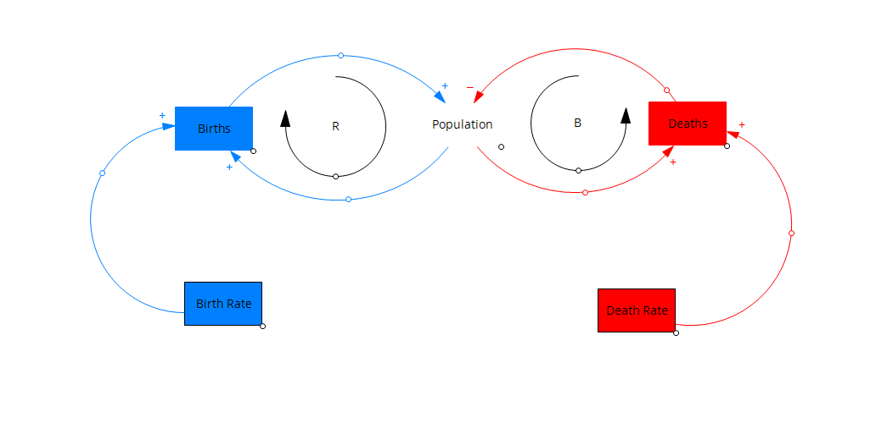

Weekly report 2

The study quantifies water use in New Zealand’s dairy food system and establishes a baseline for future sustainability. Dairy is central to New Zealand’s economy, contributing around 3.5% of GDP and 29% of export goods, with more than 95% of milk exported worldwide. However, despite its global significance, a comprehensive assessment of water use across the sector had not been completed until this research.
The authors measure both blue water (consumptive water use, such as irrigation and stock drinking) and green water (rainfall). Their systems-level analysis covers on-farm production, irrigation, and primary processing facilities.
Some key findings:
- Scale of use:
  - The dairy sector accounts for about 20% of New Zealand’s freshwater allocation (2.46 billion m³ of blue water annually).
  - When green water is included, the sector uses 12.1 billion m³ per year, with rainfall representing nearly 80%
- Breakdown of consumptive use:
  - Irrigation dominates at 92.6% of blue water use (2.28 billion m³)
  - Stock water accounts for 5.6% (137 million m³)
  - Processing uses 1.8% (45 million m³)
- Sources: About 80% of blue water comes from surface water (rivers and lakes), with the remainder from groundwater
- Regional variation:
  - Canterbury is by far the largest consumer, using over 2.1 billion m³ annually, followed by Otago.
  - Water intensity varies significantly: Canterbury has the highest consumptive water use (7.5 L/ha), while Waikato, the largest dairy region, uses very little irrigation (0.15 L/ha).
  - Regions like Canterbury and Otago rely heavily on irrigation, while areas like Southland benefit from high rainfall
- Climate pressures:
  - Rising temperatures, droughts, and altered rainfall patterns threaten the security of water resources.
  - Irrigation demand is projected to increase, especially in already water-stressed regions like Canterbury.
  - Surface water variability and limited groundwater recharge raise concerns about future supply reliability.
- Sustainability implications:
  - The dairy sector’s heavy reliance on water makes it vulnerable to climate change.
  - Operating within environmental limits and tailoring region-specific water management strategies are essential.
  - Better data collection and consistent national reporting on water use are urgently needed

Weekly Report #3

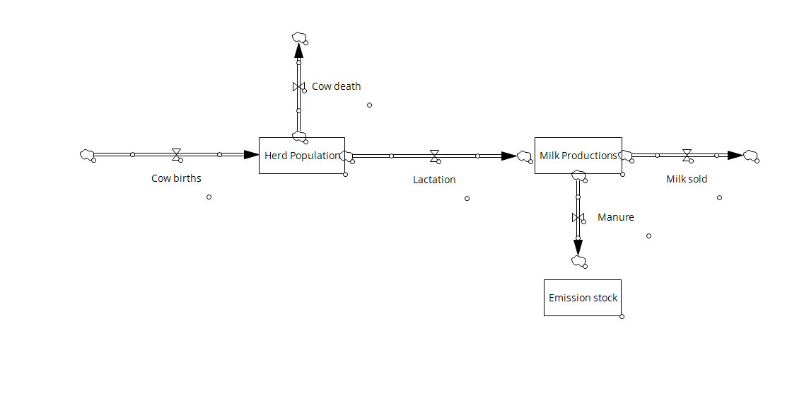

1)WEF Nexus: public policy in Latin America:
This paper explores how some Latin American countries are addressing a significant challenge: they possess substantial renewable energy resources, yet remain largely dependent on fossil fuels. This makes them economically and politically dependent on other countries. The researchers examined six countries, Mexico, Honduras, Nicaragua, Brazil, Chile, and Ecuador, to investigate their use of biogas.
- A big opportunity: Latin America and the Caribbean have one of the world's largest renewable energy sources, but almost 75% of their energy comes from fossil fuels. Using renewables, like biogas, can help them become more energy independent and help the environment.
- It's a two-for-one deal: Biogas turns environmental problems into economic and environmental wins. You get energy (electricity, heat, or vehicle fuel) and you reduce greenhouse gases. The leftovers can even be used as a liquid fertilizer.
- The countries compared:
  - Brazil: Brazil has a good energy mix, with almost half of its energy coming from renewable sources, way more than the world average. Its huge agriculture industry, especially with livestock, is perfect for developing biogas technologies from waste.
  - Mexico: Mexico's economy relies heavily on petroleum, but it's running into problems with supply. The country's livestock industry creates a lot of pollution, but it also has a big potential for biogas, which can be captured from animal waste.
  - Honduras & Nicaragua: These countries have the lowest potential for biogas, but they also have a big need for it. A lot of their energy comes from fossil fuels, and many people don't have access to electricity. Biogas could make a huge social impact in these places.
- Making it happen: The research found that all six countries have been putting new laws and policies in place to encourage the use of biogas. This shows a growing trend towards using this renewable energy source.

2) Farm Scale WEF, closed loop:

This second paper looks at how dairy farms in Texas can get rid of waste and make money at the same time. The main idea is a "closed-loop" system, which means they turn cow manure into value instead of just storing it in lagoons where it can cause pollution. The researchers created a tool to see if this idea would actually be profitable. Here's what they figured out:
- The problem: Traditional dairy farming can be bad for the environment because of manure management. When you put too much manure on the land, it can cause pollution in the air and water.
- The solution: The closed-loop system uses technology like gasification and pyrolysis to transform manure from a waste product into something useful. These processes create:
  - Biochar: A solid product that can be used to filter water, improve soil, and reduce nutrient runoff.
  - Syngas and Bio-oil: These can be used to generate electricity.
- The money side of things: The study found that this closed-loop system could be profitable. The biggest source of income for a dairy is still, of course, the milk. But the extra money from selling biochar and the savings from producing their own energy make the farm much more stable, especially when milk prices are low.
- Pyrolysis vs. Gasification:
  - Gasification makes more energy (about 29% more).
  - Pyrolysis makes more biochar (about 52% more).
  - In the end, pyrolysis was generally more profitable because biochar is worth more than the extra energy from gasification.
- The bigger picture: The research shows that this kind of system is a great way for small dairy farms to become more sustainable, both for the environment and for their business. It helps them make money, reduce their environmental footprint, and not depend on outside sources for as much water and energy.
